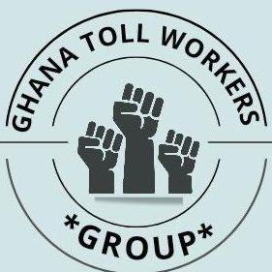
GHANA TOLL WORKERS GROUP
TEL: 0241844128, 0557689800
E-MAIL: richmat2000@gmail.com

PRESS RELEASE
Good Day Ladies and Gentlemen Of The Press.
This Press Statement is made today Thursday 17th November,2022 exactly a year since the cessation of Roads and Bridge Toll Collection in Ghana.
It will be recalled that, on 17th November,2021, the Hon Finance Minister, ken Ofori Atta, in the reading of the Budget Statement for the 2022 Fiscal Year indicated that, as a policy direction, Roads and Bridge Toll Collection will be ceased after the approval of the Budget by Parliament.
Unfortunately, even before Parliament deliberated on the Budget, the Ministry of Roads and Highways, in a rush, implemented the Cessation of Toll Collection.
This action by the Ministry of Roads and Highways plunged us, who use to man the various toll booths, into a state of shock and despair, the effect of which caused the demise of some of our colleagues.
It is sad to note that, even though it was stated in the budget that we who use to work at the various Toll Plazas will be given Alternate Livelihoods, one year down the line, not a single one of us has been given an alternate livelihood or re-assigned.
It is also worth noting that, promises made by the Hon Minister for Roads and Highways Akwasi Amoako Atta, on all three occasions that we had engaged him, and as reiterated by Hon Habib Iddrisu when he received our first Petition to Parliament on behalf of the Majority side in Parliament, that we will be given a monthly allowance whilst we wait to be re-assigned, has also not been forthcoming since January 2022. This has brought untold hardship to our members, especially, in these difficult economic times.
We have said this countless number of times, and we still stand by it, that the reason given by the Hon Finance Minister for which toll collection was zero rated is not strong enough grounds that should cause about 800 of the Citizens to lose their Jobs and Livelihood in this manner.
We also wish to emphatically state that, we have not been paid off contrary to rumors flying around in Government circles.
We therefore call on Government.as a matter of urgency, to Re-Introduce Toll Collection and recall all of us who lost our livelihoods by this action back to work so we can live in dignity and also contribute our quota to national development.
We would also like to use this opportunity to call on Civil Society including our Revered Chiefs and Religious Leaders of all faiths, to impress upon the Government to restore our dignity back by reinstating us.
Thank you.
Yours faithfully,
SIGNED
Edward Duncan Henry Dogbe
Secretary Chairman
0241844128 0557689800

Cc; All Media Houses

