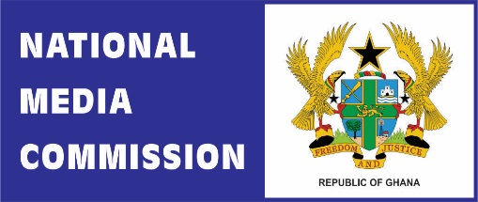
P. O. Box SD 114, Stadium, Accra
Tel: +233 (0) 302 737 514
GPS: GL-060-2379

October 18, 2023
For Immediate Release

OUTCOME OF TRIAL ON ATTACK OF UTV
The National Media Commission has noted the outcome of the trial of the persons who invaded the UTV studios. We have also noted the justifiable expression of disappointment by the GJA in what they consider as the leniency of the sentences. While the healthy discussions continue, we plead a focus to the future.
First, there is novelty in the courage of a sitting Minister, a Member of Parliament and an active politician in reporting members of his own party to the police for invading a TV station. This must signify a new beginning towards addressing questions of the safety of journalists. He and the Attorney-General and Minister for Justice had a choice. And they elected to exercise that in favour of media freedom. That behaviour sets a new standard by which government action must be judged into the future. We must hold the Ministers bound by this worthy precedent and define it as the standard by which we expect all future Ministers to act.
Second, the speed of the trial must give us hope of the commitment of the Chief Justice and the judiciary.
It is also important to acknowledge the police for arresting, investigating and prosecuting the offenders. Perhaps one positive aspect of the police action that requires to be highlighted is the responsiveness and professionalism of the commander of the Tesano Police and his team.
Above all, the outrage showed by the public should indicate to us the values Ghanaians cherish in our democratic space and the level of decency required of us all.
Social progress is sometimes slow, but the positive direction it takes can give hope of the incremental gain society stands to benefit if efforts continue in that same positive direction. As a result, we call on all who care about the safety of journalists to see the conclusion of this case as the first step towards reversing impunity. We believe our collective commitment to the Coordinated Mechanism on the Safety of Journalists will ultimately create a safer space for the practice of journalism in Ghana.
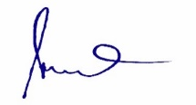
George Sarpong
Executive Secretary

